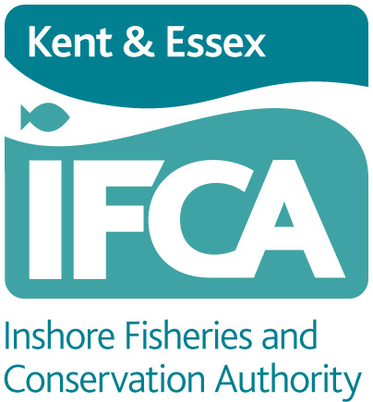
KENT AND ESSEX INSHORE FISHERIES AND CONSERVATION AUTHORIY
Paragon House, Albert Street, Ramsgate, Kent, CT11 9HD
Tel: 01843 585310 Website: www.kentandessex-ifca.gov.uk

WHELK FISHERY FLEXIBLE PERMIT BYELAW
WHELK POT PERMIT AND TAG APPLICATION FORM

NOMINATION OF PERSON TO HAUL POTS FROM NAMED VESSEL

Application to the Kent and Essex Inshore Fisheries and Conservation Authority for approval to allow a nominated person to haul pots that have been set under the conditions of a Category One permit.

Permit Holder Details:
FULL NAME OF PERMIT HOLDER:

ADDRESS OF PERMIT HOLDER:

PERMIT NUMBER:

VESSEL NAME AND PLN NUMBER:

Nominated Person Details:
FULL NAME:

ADDRESS:

TELEPHONE LANDLINE: | MOBILE:
E-MAIL ADDRESS:

DATE OF BIRTH:

Please note: the nominated person must include a copy of photographic ID, such as driving licence or passport with this application
PERMIT HOLDER

I give my consent for the nominated person named above to haul and re-set whelk pots, from the above-named vessel, which I have set under the conditions of a permit issued to me under the above byelaw. I will ensure that this person is fully aware of the wording and requirements of the Whelk Fishery Permit Byelaw.

Signed: ..................................................................... Skipper/Permit Holder

........................................................................ Name (please print)

Date: ........................................................................................................

NOMINATED PERSON

I am aware of the wording of the Whelk Fishery Permit Byelaw and that I may only operate the vessel named above to haul or reset whelk pots that have been set under the permit linked to that vessel.

Signed: .....................................................................................................

........................................................................ Name (please print)

Date: ........................................................................................................

DATA PROTECTION

The data supplied on this form is covered by the General Data Protection Regulations 2016. Kent & Essex IFCA has the right to process this data under Article 6(1)(c) of this Act as your data fulfils a legislative function. Your data is processed by Kent & Essex IFCA under a legal obligation conferred in sections 155 & 156 of the Marine and Coastal Access Act 2009 to process your permit, as is required by the Whelk Fishery Flexible Permit Byelaw.

We will only use your data provided on this form to process and monitor your permit. This consent to do so will remain in force until the permit ceases. You have the right to withdraw your consent for this at any time however, this will revoke the permit. The data is also held securely on Kent & Essex IFCA’s server.

In addition, we use your data to send you information on upcoming changes to legislation, formal and informal consultations on future byelaws and wider initiatives that may affect you. You have the right to withdraw your consent for this at any time.

We retain your data for three years following your application for a permit, after which it will be removed and destroyed. Electronic copies also have personal data removed three years after the permit has been issued.

If you would like to access any of the information we hold about you, or you have concerns regarding the way we have processed your information, please contact: Will Wright, Data Protection Officer, KEIFCA, Paragon House, Albert Street, Ramsgate, Kent, CT11 9HD. Telephone 01843 585310 or email will.wright@kentandessex-ifca.gov.uk

On occasions we are asked to supply information/data to other statutory bodies. If you are willing for your contact details to be shared, please tick the box below.

I give consent for my contact details to be shared

